Câu 1:

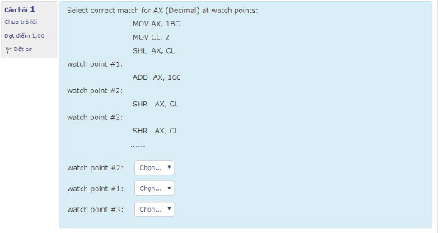

#1=2133

#2=444

#3=444

Câu 2: Convert the 8-bit floating point number 68 (in hex) to decimal.

Convert and separate: 68 hệ 16 = 01101000 hệ 2

Exponent: 110 = 6; 2 − 3 = 3.

Denormalize: 1.1000 × 2^3 = 1100

Convert:

Exponents 2^4 2^3 2^2 2^1 2^0

Place Values 16 8 4 2 1

Bits 0 1 1 0 0

Value 0 8 + 4 = 12

Sign: positive

Result: 12 is 12.

Câu 4 :

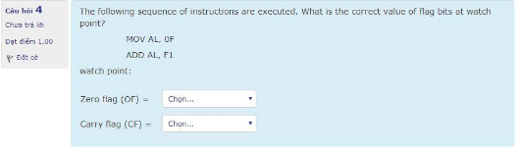

OF=0 ; CF=1

Câu 6 :

Seek time :time to position heads over cylinder containing

targrt sector

Rotational latency :time waiting for first to of target sector to pass under r/w head

Transfer time (tavg transfer) : time to read the bits in the target sector

Câu 7 :Convert -89.2345 to IEEE 32-bit floating piont format(1s +8e+23m) in hex

1100 0010 1011 0010 0111 1000 0001 0000

Câu 8: In the interconnection system among computer components(e.g…CPU,Memory,I/) the number of address line governs:

1. The maximum physical memory size that the CPU can address
2. Size of memory word
3. Size of cache memory
4. Size of I/O port

Câu 9

Câu 11:

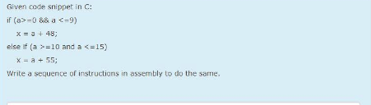

cmp a, 0

js L2

cmp a, 9

jg L2

add a, 49

mov x, a

jmp .L3

L2:

cmp a, 9

jle L3

cmp a, 15

jg L3

add a, 55

mov x, a

L3:

Câu 12 : Six level Computer

Level 0: Digtal logic level

Level 1: Microarchitecture level

Level 2: Instruction set architecture level

Level 3: Operating system machine level

Level 4: Assembly language level

Level 5: problem- oriented language level

Câu 13:

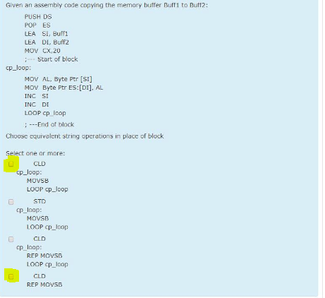

Câu 14: choose correct set of register for x86 processor

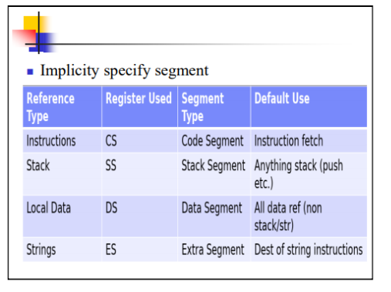

Câu 16 : convert the folling number from the base shown to base 10

777 (base 8) =511

FEC (base 16) =4046

111 (base 8)=73

777 (base 16)=1911

111(base 2)=7

Câu 17 : match the decimal value ò the following 2’s complement

11010110 : 42  
 10010111 :105

1101000 : 48ư

Câu 18 : to encrypt a byte value, use _____ instruction

1. Not
2. And
3. Or
4. Xor

Câu 19: after each excution of push instruction, the stack pointer is

1. Decrement by 1
2. Decrement by 2
3. Increment by 2
4. Increment by 1

Câu 20 :D

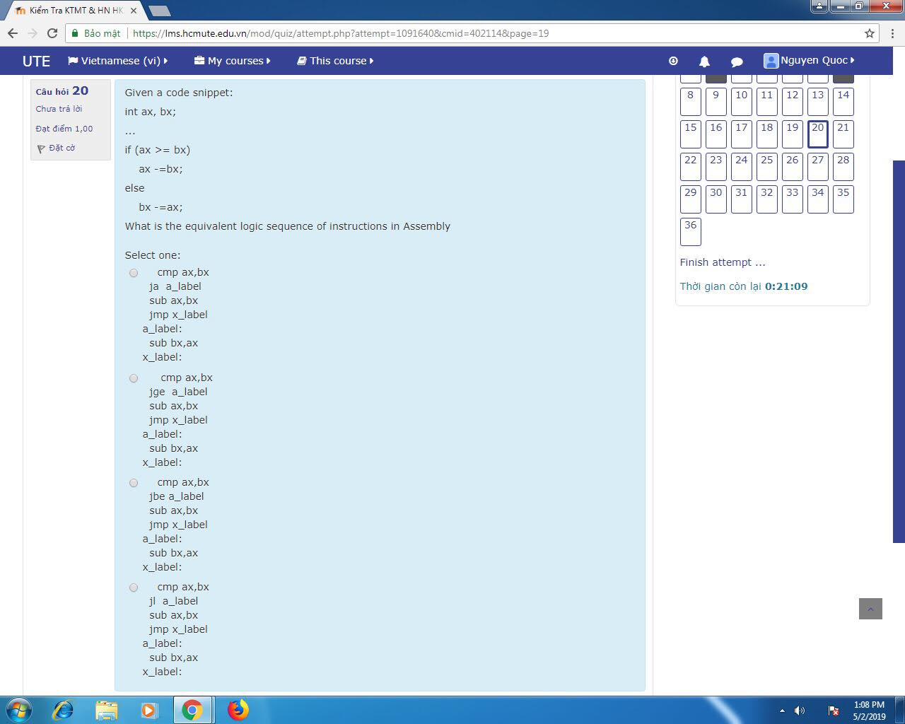

21.

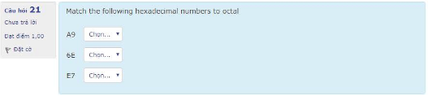

A9=251

6E=156

E7=347

Câu 22:D

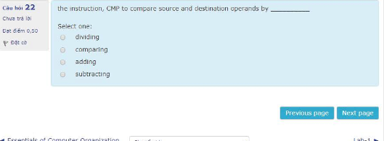

Câu 24 :

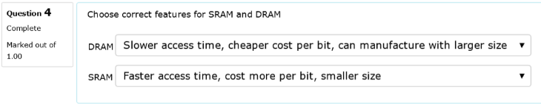

Câu 25 :

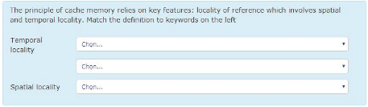

Temporal: a memory content referenced will be referenced again in the near future ν

Spatial: if a memory content has been referenced, its neighborhood will be referenced as well in the near future ν

Algorithmic: some algorithms (like traversing linked lists) refer to the memory in a systematic way

Câu 26:

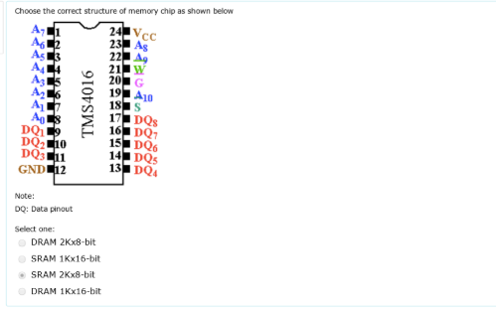

Câu 27: In multiplocation instruction, the result is taken from AX means the source operand is _____ bit

1. 16
2. None of the choices are correct
3. 4
4. 8

Câu 28 :

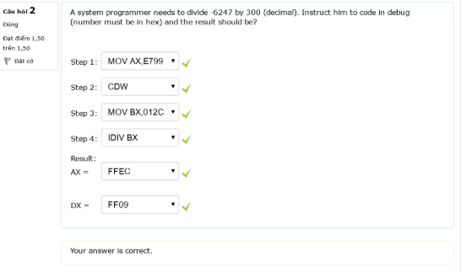

Câu 30 .

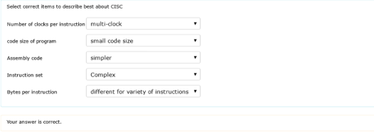

Câu 32:

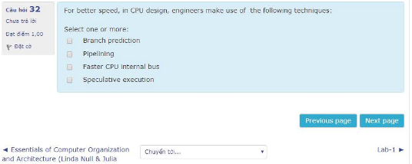

Chọn all

Câu 33:

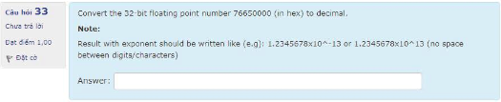

1.16116794980905813177098013612^33

Câu 35:

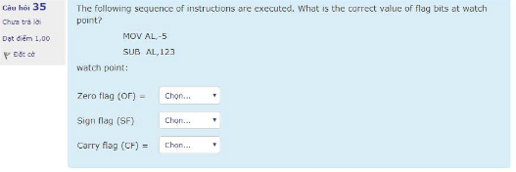

of=1 sf=1 cf=0